A Lextiles Bot

Background and Motivation
Lextiles is a fun, challenging word game available online at lextiles.com. Lextiles is played on a 6 by 6 board of letters, each letter with a corresponding score, as in Scrabble. A word is formed by connecting adjacent letters, which removes the tiles from the board, allowing new words to be formed. Certain tiles are placed on powerup squares, which can increase the score of a played word in various ways depending on the powerup. There are also three tile swaps available to the player throughout the game, where two adjacent tiles can be swapped to allow for play of previously unavailable words. According to the home page of the site, “The goal of Lextiles is to score as many points as possible using the tiles given.” The goal of this project is to do exactly that: score as many points as possible, by any means possible. So, I set out to make a Lextiles bot.

For the record, I’d like to think that I’m pretty decent at this game without the help of a computer. But I’m not the best. Looking at you, Player_3875. My goal for the Lextiles bot is to put Player_108088 on the map forever. Specifically, write a program that tells me what words to play to consistently be the first name on the leaderboard every day.

Problem Analysis

There are many ways to play any given Lextiles board. Only one of these is the best solution, the solution that gives you the most points. It might appear that finding the highest-scoring solution is still quite simple. Just simulate every possible combination of moves, score every final board state, and pick the best one! So easy.

Before we start writing our optimal Lextiles solver, let’s see how feasible it is with some back-of-the-napkin math. In the starting state there are 110 possible swaps. Each of the 4 corner tiles has 3 adjacent tiles (12 possible swaps), the 16 edge tiles each have 5 adjacent tiles (80 swaps), and the 16 center tiles each have 8 adjacent tiles (128 swaps). Adding these up, we have 220 possible swaps. Through this process, we’ve double counted each swap, because swapping tile A with tile B is the same as swapping tile B with tile A. So, we have 110 unique playable swaps from the starting position. [Double check this]

From the starting position, we also have some number of words we can play. Depending on the letters and their positioning, the number of playable words may fluctuate.

To estimate the number of playable words from the starting position in general, we can find the exact number of playable words on a few different boards and take the average. With a dictionary in the form of a trie, running depth-first search on a board looking for valid words becomes an easy task. On May 1, 2026, (the time of writing for this paragraph), the daily board has exactly 72,391 playable words from the starting position. [wrong!, you accounted for swaps here, this number is off by a factor of around 100 (from 110 possible swaps)] That’s a lot. By eyeballing the leaderboards, games typically last 6 to 9 words. Even if the next 5 subsequent boards after playing words only have 1000 words available, the number of possible combinations is easily on the order of 10^15 or 1 quadrillion. My CPU can run about 2 teraflops, or about 2*10^12 operations per second. Even if finding a single word only took one operation (which it doesn’t), it would still take around 1000 seconds around 16(?) minutes. In practice, it would take much longer. I’m not planning on buying compute, so brute force won’t work. We will do some more complete search space size estimation later. For now, let’s introduce the Lextiles bot.

Process
Game simulation
Before we start writing a solver, we need to simulate the game. Fortunately, this wasn’t too hard. I decided to use python. Even though it’s certainly not the fastest language out there, it makes for easy development. I represented the grid of letters and powerups as two 2D arrays and also initiated a dictionary mapping each letter to its score. I created a Coordinate class, simply an ordered pair plus support for “adding” of offsets such that Coordinate(2, 2) + Coordinate(1,1) = Coordinate(3,3), which is a useful property for iterating through the board. I then created a Swap class, composed of two coordinates, with the added functionality that Swap(Coordinate(A), Coordinate(B)) is equivalent to Swap(Coordinate(B), Coordinate(B)). I felt that words didn’t need their own class, as list of Coordinates works just fine. A function called update_board takes in a word in the form of a list of Coordinates and a Swap and then simulates the game logic. With this infrastructure in place, coding solvers becomes easier.

Greedy

The first approach I tried was a greedy solver. Search every possible word on the board, find the best one and play it. Repeat until no moves are left. The issue with this approach so far is that we haven’t considered swapping tiles. A greedy approach without swaps will manage to score in the top 100, but not using your swaps leaves out a lot of possibilities. Unfortunately, swaps score 0 points. So, a greedy approach has no incentive to swap. The workaround I used for this was to consider an atomic action to be a combination of an optional swap and a word, rather than just a swap or word. That is to say that the output of the solver would be of the form ([swap], word), (<- make this the actual format, I forgot what it’s called), rather than (swap or word). In order to make this work, when generating the set of all possible swaps to consider, one of the swaps included is the “identity swap”, or a swap that does not affect the game state. When no swaps are left, the only possible swap allowed to play will be the identity swap. With this new action format, the greedy solver has no incentive not to swap, as a word will always score points, so a swap comes at no extra cost. In practice, the greedy solver almost always uses up its swaps as soon as possible, as most of the high-scoring words involve a swap. So, at every branch, the greedy solver considers a swap, finds all possible words using the swap, and then moves on to considering the next swap. After considering all combinations of swaps and words, it outputs the highest-scoring combination.

This solver works well but is far from perfect. On occasion, greedy will end up being top of the leaderboard, but often only makes it to the top 5, or even top 10. The issue with a greedy algorithm here is that while you may be able to make a really high-scoring word right off the bat, a situation often occurs where two medium-scoring words are better than a high-scoring one and a low-scoring one. An example is given below [example]

There is yet another issue with this greedy solver, but I would posit that this is a rather small effect. At any given turn, you are allowed to use as many swaps as you have left. So for something like the first turn, you could actually consider all combinations of up to three swaps plus a word. In practice, this would mean swapping three times and exhausting all available swaps before playing your first word. To consider three swaps, there are 110*109*109= 1,306,910 combinations. (Make this a footnote (but better): I’m pretty sure that the second 109 is not a typo. You start with 110 swaps, then for the second swap you don’t want to repeat, so you only have 109 swap options. For the third swap, you don’t want to repeat the last one, but you could actually repeat the first swap without ending up with the same state, so you still have 109 swap options. Include diagram?). Of course, scanning the entire board for all words a million times is not very feasible. Even only considering two swaps at once greedily, we still need to consider two orders of magnitude more combinations than just one swap, a significant hit to runtime. In some of the best runs in the Lextiles leaderboard, I have observed that sometimes a player will actually use two swaps in one turn, so this technique is in fact used. That being said, our greedy solver works fine with this limitation, and we will now move on to improving our Lextiles bot with other methods.

Solving techniques in search of a heuristic

In order to improve greedy, I considered potentially adding heuristics to the model, such that certain words could be considered to be better than others even with a strictly worse score. I call this kind of move a “quiet move.” For an example, take this board state:
O | T
N | I |  |  |  | Y
S | V | DS |  |  | R
O | A |  | TS | T | Q
O | S | U |  | C | C
I | N | E | H | H | E

While swapping the o with the a in row 3 (0-indexed) allows for the play of the word NOVAS for more points, it would be better to play a word like HUE or CHUSE that collapses the tiles to the right, meaning that when NOVAS is played on the next turn, it scores higher than it would’ve earlier, because of the powerup coverage. Any experienced Lextiles player worth their salt will notice this property. But of course, a greedy solver will not care. One consideration I had at this point was to add a certain bonus to words that lead to a better board state. For example, when the solver considers the word CHUSE, it would also be notified that the proceeding board state covers more powerups than it did before. If CHUSE scores x amount of points, when the powerups property is fulfilled, the solver will internally consider it to score x+b amount of points, where b corresponds to the bonus number of points given by the powerups heuristic. With this, the solver would be more likely to choose CHUSE rather than NOVAS, potentially leading to a higher score. The difficulty with this approach is tuning the bonus to align with optimal play, a task that is not at all trivial. Fortunately, we will later cover some techniques that help approximate this idea implicitly.

Another potential heuristic I considered was a swap penalty. When there are only a few rounds left in the game, you should always use your swaps when they improve your immediate score, because you won’t be needing them later. Conversely, early in the game, it may sometimes be wise to conserve a swap for when you may need it more later, even if you don’t play the absolute best word early on. Including some kind of penalty for using a swap early, allowing the solver to explore more unswapped options could lead to using swaps more wisely, and scoring higher in the long run. This again is a difficult penalty to quantify.

Another technique worth mentioning is what I call the “hidden swap” technique. This is any time that a player will swap two tiles, then use neither of the swapped tiles to make their next word. Typically, tiles are swapped in order to make a previously unplayable word playable. For example, if the board is:
 | L | E
 | X | C | I | A | L

it would make sense to swap the i with the c in order to play the word lexical. Elementary. Yawn. A more interesting way to swap is demonstrated in the following state I constructed:

 |  | T | C | U | O
 |  | N | N | A | C
 |  | T | U | T | R
 |  | Q | A | A | Z
 |  | T | C
 |  | N | N | U | O
 |  | T | A | A | C

I’d first like to draw your attention to the best word on the board: QUARTZ, highlighted in green. Playing QUARTZ leads to the next state. Sadly, there aren’t many great words on this new board. If only we could swap the highlighted A with the highlighted C we could play the word ACCOUNTANT, not a small word indeed. Unfortunately, these tiles aren’t adjacent. Or are they? Looking at our first state, we see that A and C were in fact adjacent just one move ago. If we had swapped those two tiles earlier, then we would later be able to play ACCOUNTANT, clearing the board. Swapping A and C is a “hidden swap.” It’s a swap that we could “play” in the latter board state as long as we know the previous board state and set up the board in advance. This is quite a delicate technique, one that may have been difficult to find had I not had the priviledge to watch some of the old masters of Lextiles play their game. I stand on the shoulders of giants.

We will soon go into how we deal with approximating these techniques, and will find that some are harder to deal with than others.

Getting the word list

Gone without mention until now is another limitation of the Lextiles bot at this point. The dictionary I used was different than the dictionary Lextiles uses. To get around this, when running the program, the bot asks you to play a word, but if it turns out that the word is unplayable because it’s not in the Lextiles dictionary, you could press a key to tell it to find the next best word. This was annoying, but not so bad. A more unfortunate occurrence was when the solver suggested a word that was the best in its dictionary, but there existed a word that was better that was only contained in the Lextiles dictionary. This meant that the greedy solver would sometimes miss the greediest word. At this point in the project, I wanted to call it done. It was a good run, but nothing more complicated could be done without the one and only Lextiles Internal Dictionary ™.

I was describing my plight to a friend during some downtime in my TA office hours (I’m such a good student please hire me), as I showed her the project. We talked about how nice it would be to have the internal dictionary, if only they had it on the client side. What follows is a series of fortunate events. We open the website, and open the developer tools. We see the following console log: “Word list downloaded”. We see that the log comes from a particular JS file. We open the file. Find that the word list is simply found on the endpoint /wordlist.json.gz. We visit the endpoint. Bam. Right before our eyes, a mysterious and untrusted zip file has been downloaded onto my machine. War is over! I then open the file in a virtual machine for a little bit of extra security just in case wordlist.json.gz is actually just a really clever trap to get in the way of Lextiles cheaters like myself. When opened, wordlist.json.gz revealed itself to be exactly what it said it was, a word list. Now we’re cooking with gas.
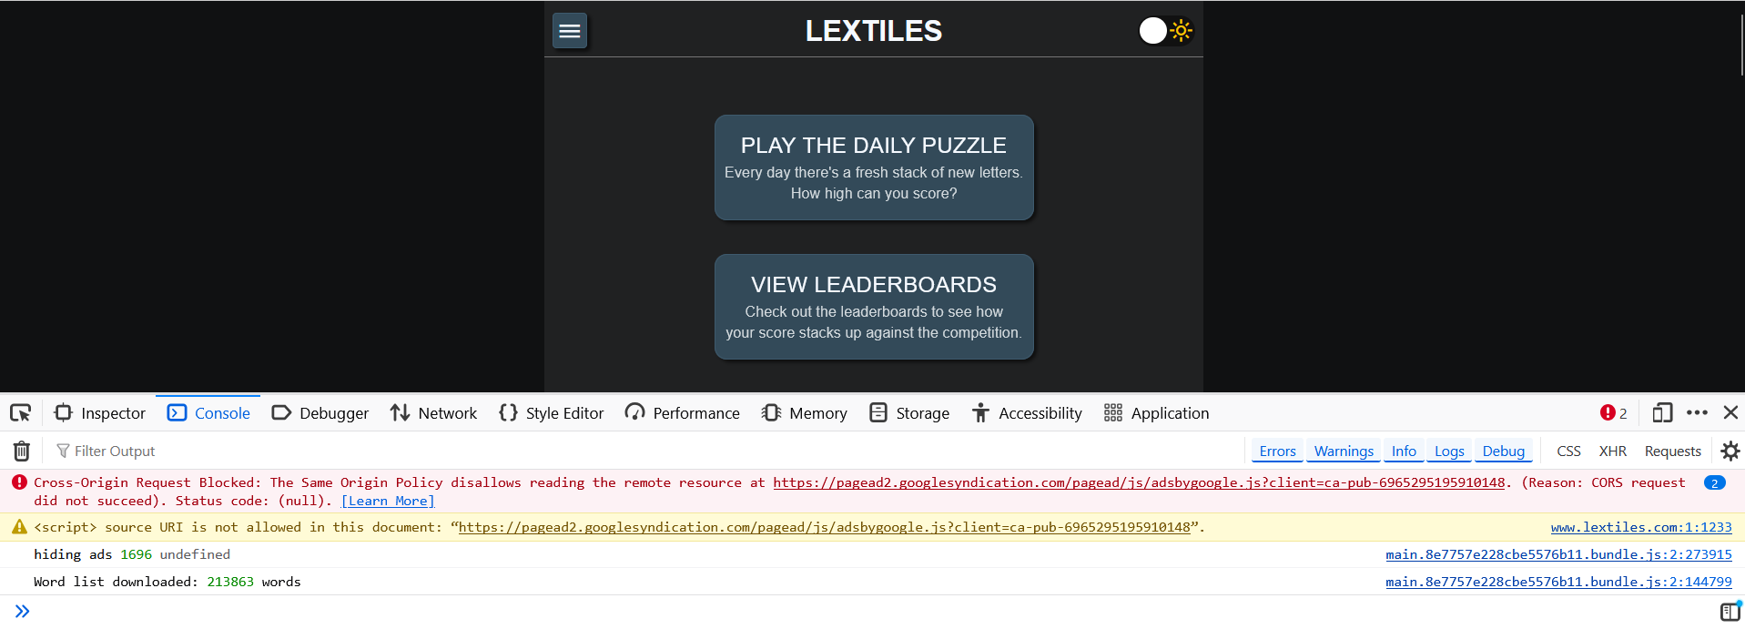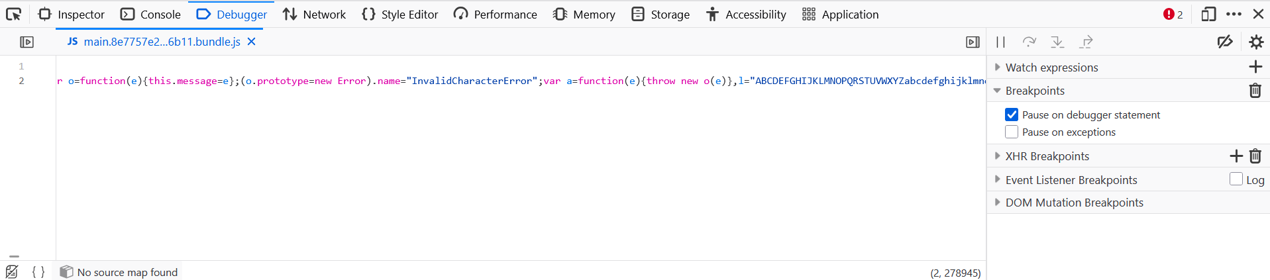

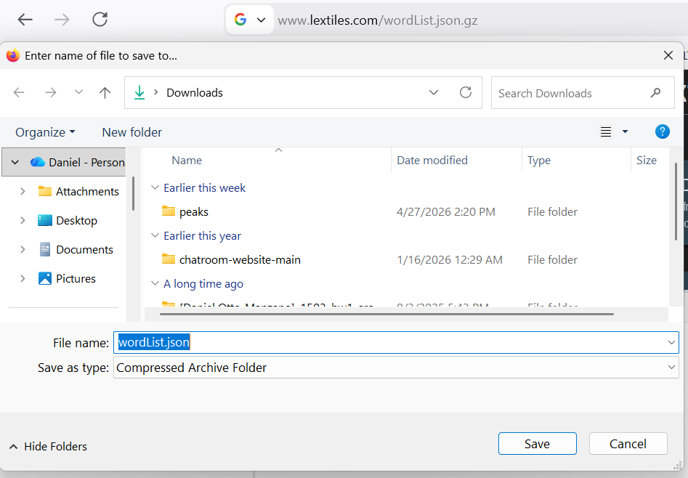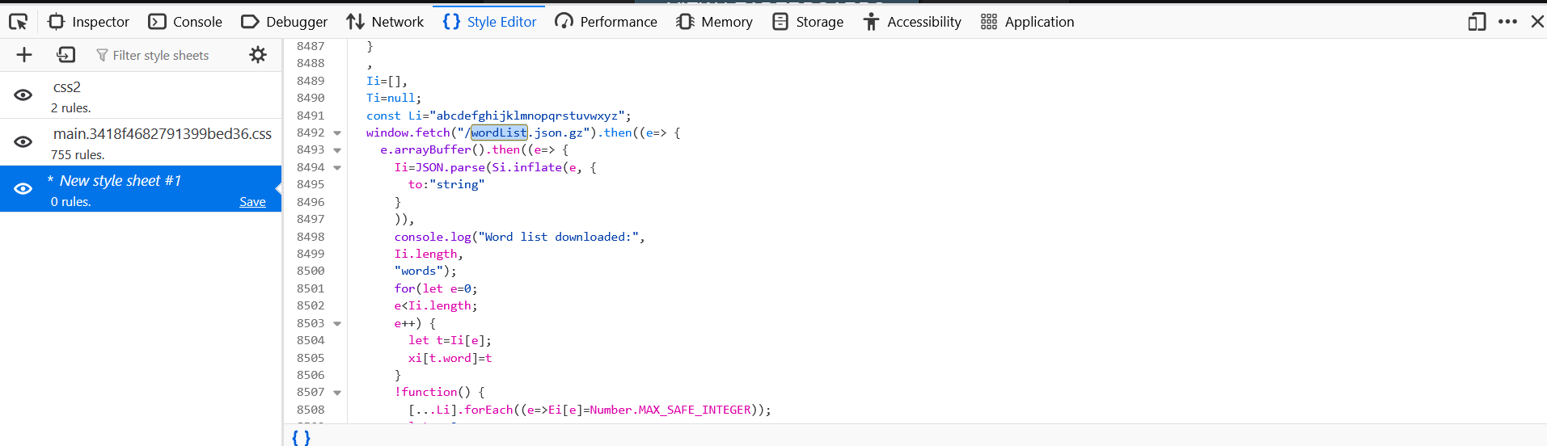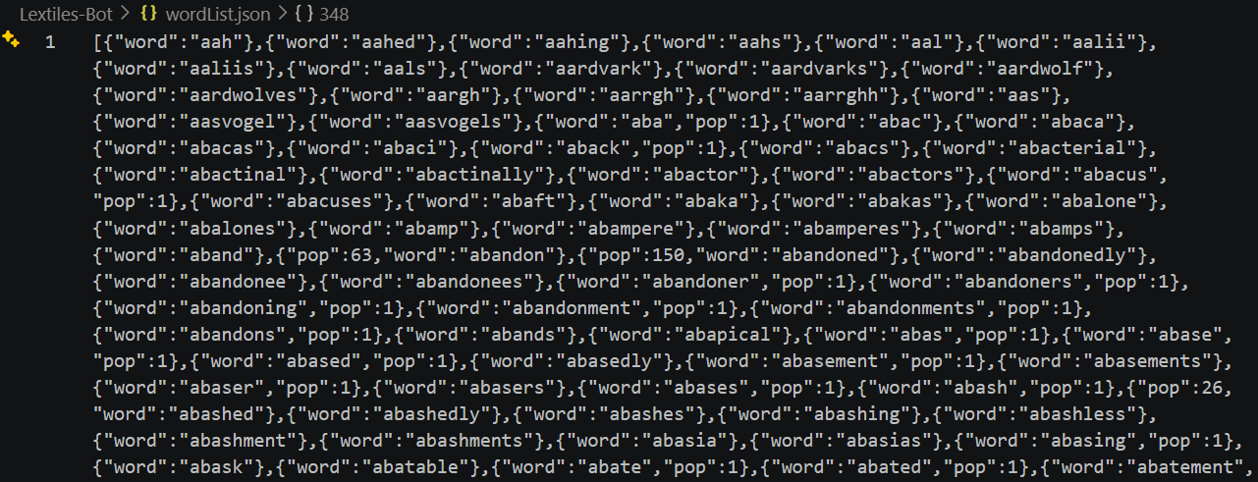

Monte Carlo Tree Search

Monte Carlo Tree Search is a technique named after Don Carlos, a Spanish conquistador who used randomized walks through South America to find the mythical gilded tree of El Dorado.

I made that up. I hope you didn’t believe me. Mone Carlo Tree Search is actually what will allow our Lextiles Bot to get to the next level

Outline
- Background
- What is Lextiles
- Motivation and Problem Analysis
- Why make a solver?
- What constitutes success?
- Can we do brute force?
- Search space size intuition, swaps, word amount at layer 1
- Include search space code later in process section
- Solving Techniques and Potential Heuristics
- Hidden swap technique
- Powerups covered heuristic
- Process
- Initial game simulation and prompting solver with greedy
- Explanation of swap+move atomicity structure
- Getting the word list
- Monte Carlo Tree Search (word list was needed for this)
- Search space size estimation
- Future
- Results
- Use real data examples and generated data examples
- Conclusion
- Flex on 'em

JUST START THIS, BREVITY IS THE SOUL OF WIT

